## Use Case Diagram

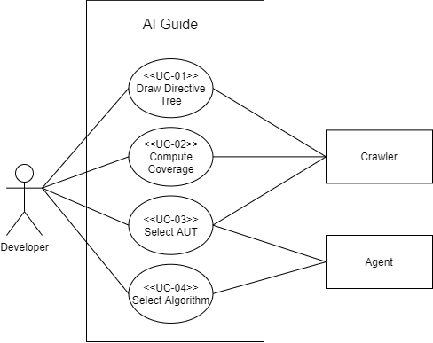

## Use Cases

|  |  |
| --- | --- |
| **No** | UC-01 |
| **Use Case Name** | New File |
| **Scope** |  |
| **Level** | User-goal |
| **Primary Actor** | User |
| **Stakeholders and Interests** | User: Anyone who needs to create a file. |
| **Preconditions** | None. |
| **Success Guarantee** | Create or overwrite files. |
| **Main success Scenario** | 1. User taps “New file” button. 2. Input a string as the filename. 3. Tap “SAVE” button. 4. App create a file. |
| **Extensions** | 2a. User taps a exist file.   1. Tap “SAVE” button. 2. App will ask the user whether to overwrite the file. 3. Tap “OK” button   2b. Input a file name that already exist.   1. Tap “SAVE” button 2. App create a file that named file name + (1)   2c. User didn’t input anything.   1. Tap “SAVE” button 2. App create a file that named (invalid) |
| **Special Requirements** | None |
| **Technology** | None |
| **Frequency of Occurrence** | Often |
| **Miscellaneous** | None. |

|  |  |
| --- | --- |
| **No** | UC-02 |
| **Use Case Name** | Open a file |
| **Scope** |  |
| **Level** | User-goal |
| **Primary Actor** | User |
| **Stakeholders and Interests** | User: Anyone who needs to open file. |
| **Preconditions** | None. |
| **Success Guarantee** | File successfully opened |
| **Main success Scenario** | 1. User taps “Open a file” button. 2. User taps on the file that he wants to open. 3. File opened. |
| **Extensions** | 2a. User taps a folder.   1. Open the folder.   2b. User taps return.   1. Return to App home. |
| **Special Requirements** | There must be files. |
| **Technology** | None |
| **Frequency of Occurrence** | Often |
| **Miscellaneous** | None. |

|  |  |
| --- | --- |
| **No** | UC-03 |
| **Use Case Name** | Open recent files |
| **Scope** |  |
| **Level** | User-goal |
| **Primary Actor** | User |
| **Stakeholders and Interests** | User: Anyone who needs an editor |
| **Preconditions** | UC-02 |
| **Success Guarantee** | File successfully opened |
| **Main success Scenario** | 1. User at App home page. 2. User taps file name at App home page. 3. File opened. |
| **Extensions** | 2a. User taps X beside file name at the App home page.   1. File closed. |
| **Special Requirements** |  |
| **Technology** |  |
| **Frequency of Occurrence** | Often |
| **Miscellaneous** | None. |

|  |  |
| --- | --- |
| **No** | UC-04 |
| **Use Case Name** | Save file |
| **Scope** |  |
| **Level** | User-goal |
| **Primary Actor** | User |
| **Stakeholders and Interests** | User: Anyone who needs to save file. |
| **Preconditions** | UC-02. |
| **Success Guarantee** | File successfully saved. |
| **Main success Scenario** | 1. User input “test” in editor. 2. User taps “SAVE” icon. 3. User taps “Save” button 4. File successfully saved. |
| **Extensions** | 3a. User taps “Save as”   1. App show the file explorer. 2. Input a new filename. 3. User taps “SAVE” button. 4. File successfully saved.   2a. User taps return.   1. App show dialog. 2. User taps “SAVE” button. 3. File successfully saved.   2b. User taps return.   1. App show dialog. 2. User taps “NO” button. 3. Fail to save.   2c. User taps return.   1. App show dialog. 2. User taps “CANCEL” button. |
| **Special Requirements** | None |
| **Technology** | None |
| **Frequency of Occurrence** | Often |
| **Miscellaneous** | None. |